BIG DATA ANALYTICS LAB
Exp-2. Implement following applications using Mapreduce on single node cluster
(i) Word Count Application

Date: 29-01-2025

hadoop@ubuntu22:~$ cd Desktop/RMMBDALAB/MapReduce/wordcount
hadoop@ubuntu22:~/Desktop/RMMBDALAB/MapReduce/wordcount$ ls
'mapredcue executed steps 12-08-2024' myfile-ip text wcred.py
'mapredcue executed steps 12-08-2024.doc' python-mapreduce-instructions wcmap.py word.txt

hadoop@ubuntu22:~/Desktop/RMMBDALAB/MapReduce/wordcount$ cat word.txt
Bus, Car, bus, car, train, car, bus, car, train, bus, TRAIN,BUS, buS, caR, CAR, car, BUS, TRAIN, Bus, Car, bus, car, train
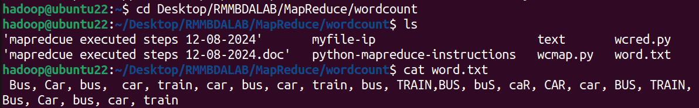
hadoop@ubuntu22:~/Desktop/RMMBDALAB/MapReduce/wordcount$ python3 wcmap.py <word.txt
Bus, 1
Car, 1
bus, 1
car, 1
train, 1
car, 1
bus, 1
car, 1
train, 1
bus, 1
TRAIN,BUS, 1
buS, 1
caR, 1
CAR, 1
car, 1
BUS, 1
TRAIN, 1
Bus, 1
Car, 1
bus, 1
car, 1
train 1

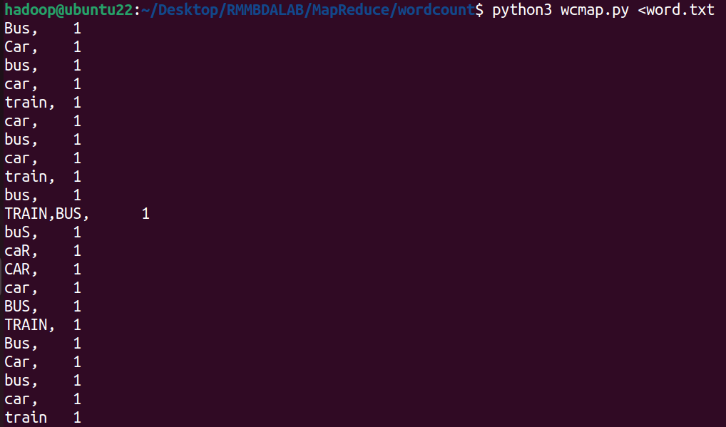
hadoop@ubuntu22:~/Desktop/RMMBDALAB/MapReduce/wordcount$ cat word.txt | python3 wcmap.py | sort -k1,1 | python3 wcred.py
bus, 4
buS, 1
Bus, 2
BUS, 1
car, 5
caR, 1
Car, 2
CAR, 1
train 1
train, 2
TRAIN, 1
TRAIN,BUS, 1

hadoop@ubuntu22:~/Desktop/RMMBDALAB/MapReduce/wordcount$
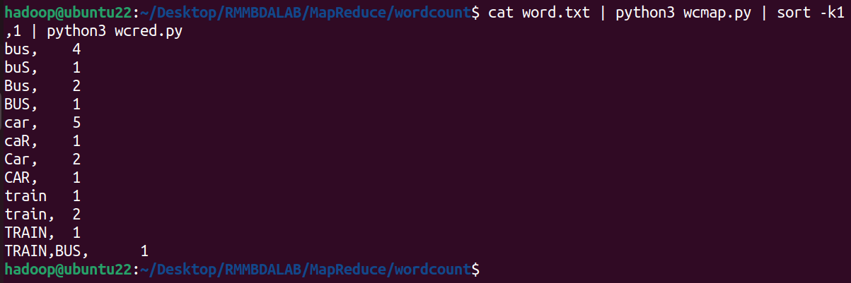
Running on Hadoop Cluster:

hadoop@ubuntu22:~/Desktop/RMMBDALAB/MapReduce/wordcount$ start-all.sh

Starting namenodes on [localhost]
Starting datanodes
Starting secondary namenodes [ubuntu22]
Starting resourcemanager
Starting nodemanagers

hadoop@ubuntu22:~/Desktop/RMMBDALAB/MapReduce/wordcount$ jps
7200 NodeManager
6598 DataNode
6459 NameNode
6812 SecondaryNameNode
7709 Jps
7070 ResourceManager

hadoop@ubuntu22:~/Desktop/RMMBDALAB/MapReduce/wordcount$

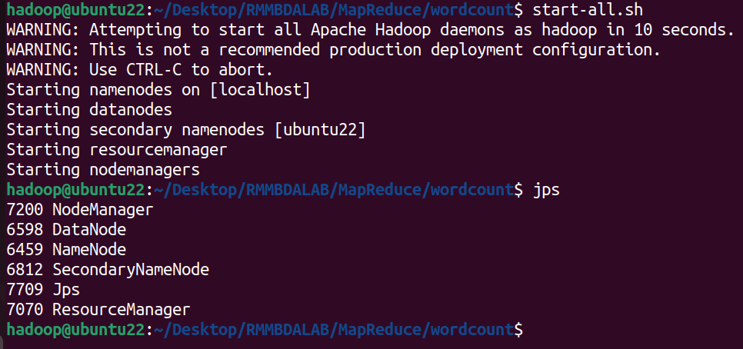

hadoop@ubuntu22:~/Desktop/RMMBDALAB/MapReduce/wordcount$ hadoop fs -mkdir -p /rmm_wordcount

hadoop@ubuntu22:~/Desktop/RMMBDALAB/MapReduce/wordcount$ hadoop fs -copyFromLocal word.txt /rmm_wordcount

hadoop@ubuntu22:~/Desktop/RMMBDALAB/MapReduce/wordcount$ hadoop fs -ls /rmm_wordcount
Found 1 items
-rw-r--r-- 1 hadoop supergroup 125 2025-01-29 11:11 /rmm_wordcount/word.txt

hadoop@ubuntu22:~/Desktop/RMMBDALAB/MapReduce/wordcount$

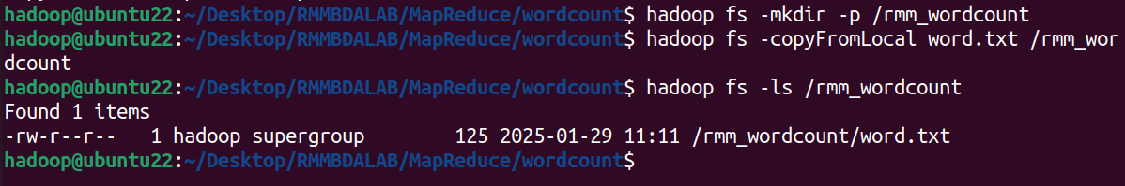
hadoop@ubuntu22:~/Desktop/RMMBDALAB/MapReduce/wordcount$ hadoop jar /home/hadoop/hadoop/share/hadoop/tools/lib/hadoop-streaming-3.3.6.jar -file wcmap.py -mapper "python3 wcmap.py" -file wcred.py -reducer "python3 wcred.py" -input /rmm_wordcount/word.txt -output /rmm_wordcount/output1

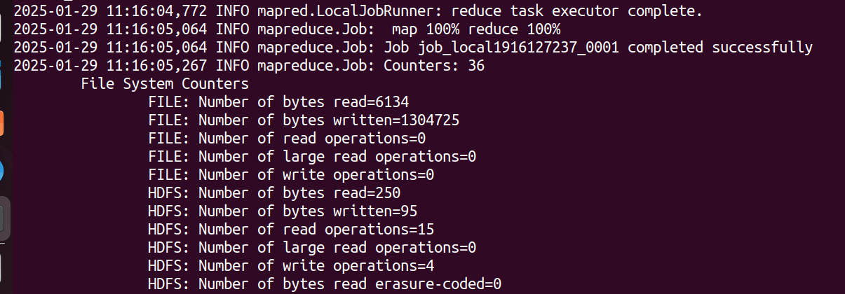

Output Location:

hadoop@ubuntu22:~/Desktop/RMMBDALAB/MapReduce/wordcount$ hadoop fs -cat /rmm_wordcount/output1/part-00000
BUS, 1
Bus, 2
CAR, 1
Car, 2
TRAIN, 1
TRAIN,BUS, 1
buS, 1
bus, 4
caR, 1
car, 5
train 1
train, 2

hadoop@ubuntu22:~/Desktop/RMMBDALAB/MapReduce/wordcount$

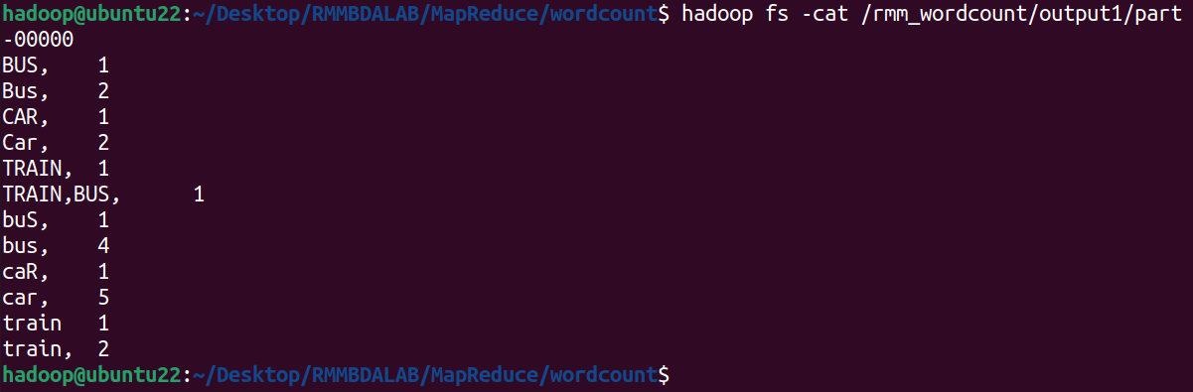

Source Files:

word.txt:
Bus, Car, bus, car, train, car, bus, car, train, bus, TRAIN,BUS, buS, caR, CAR, car, BUS, TRAIN, Bus, Car, bus, car, train

Mapper Python Code:

#!/usr/bin/env python2
"""wcmap.py"""

import sys

# input comes from STDIN (standard input)
for line in sys.stdin:
# remove leading and trailing whitespace
line = line.strip()
# split the line into words
words = line.split()
# increase counters
for word in words:
# write the results to STDOUT (standard output);
# what we output here will be the input for the
# Reduce step, i.e. the input for reducer.py
#
# tab-delimited; the trivial word count is 1
print('%s\t%s' %(word, 1))

Reducer Python Code:

#!/usr/bin/env python2
"""wcred.py"""

from operator import itemgetter
import sys

current_word = None
current_count = 0
word = None

# input comes from STDIN
for line in sys.stdin:
# remove leading and trailing whitespace
line = line.strip()

# parse the input we got from mapper.py
word, count = line.split('\t', 1)

# convert count (currently a string) to int
try:
count = int(count)
except ValueError:
# count was not a number, so silently
# ignore/discard this line
continue

# this IF-switch only works because Hadoop sorts map output
# by key (here: word) before it is passed to the reducer
if current_word == word:
current_count += count
else:
if current_word:
# write result to STDOUT
print('%s\t%s' % (current_word, current_count))
current_count = count
current_word = word

# do not forget to output the last word if needed!
if current_word == word:
print ('%s\t%s' % (current_word, current_count))

